
POC TECHNICAL EVALUATION
VisualBase fitness for NCGR
inventory and production
Evidence-led platform decision before development begins

Prepared for: NCGR engineering, product, security, and architecture leadership
Assessment date: 2 September 2026
Decision point: Select the foundation before inventory and production development starts
POC outcome: Conditional NO-GO for VisualBase based on the evidence currently demonstrated
Recommended direction: Start greenfield on .NET 10 LTS and ABP
Decision confidence: Medium-high; the recommendation is reversible only if all critical gates are proven

Executive recommendation: Do not begin the strategic inventory and production product on VisualBase on the strength of the current POC. The POC shows credible speed for data-centric forms and workflow, but it does not yet prove the correctness, release governance, security, operability, or independent ownership required for a government system of record. Start greenfield on .NET 10 LTS with ABP unless VisualBase passes every critical engineering and contractual gate. Receiving platform source code after the project is complete reduces one continuity risk, but does not by itself remove proprietary-runtime, build-toolchain, knowledge, data-model, or upgrade lock-in.
Classification: Internal engineering decision support

Executive recommendation
The POC result supports a conditional NO-GO for VisualBase as NCGR's strategic inventory and production foundation. The platform is demonstrably capable of generating bilingual data-entry screens, workflow actions, approvals, reports, and configuration rapidly. Those are genuine delivery advantages. However, the decision is not about the quality of a demonstration or the existence of screens; it is about whether NCGR can safely own, change, test, operate, secure, and evolve the resulting system for years.
The central concern is architectural, not cosmetic. VisualBase deliberately replaces conventional compiled application code with a runtime engine that interprets database structures and stored business definitions. The vendor describes screens as generated on first call, business logic as stored in a database repository, and rules as changeable while viewing live data [S1][S2]. The authenticated NCGR demo exposes the same model through Object Management, validation records containing SQL queries, event hooks, approval events, security flags, and insert/update commands [S4].
Decision principle: Low-code reduces visible coding effort; it does not remove domain complexity. In VisualBase, much of that complexity becomes implicit, database-resident, and editable at runtime. For inventory and production, NCGR needs critical rules to be explicit, versioned, reviewable, testable, deployable, observable, and recoverable as engineering artifacts.

Decision summary
Decision area | Recommendation | Status
Strategic system of record | Do not approve VisualBase on current POC evidence. | RED
Limited low-risk use | May be considered for disposable prototypes or non-critical administrative forms after data classification. | AMBER
Target foundation | Use .NET 10 LTS + current stable ABP in a modular monolith, with SQL Server persistence. | GREEN
Reconsideration condition | Reconsider only if all critical technical and contractual gates are independently demonstrated. | AMBER

Background and decision question
NCGR leadership requested this proof of concept before product development begins. The decision is whether to use the vendor's VisualBase low-code platform for the inventory and production product, or to follow NCGR's established product-engineering direction and build a greenfield solution on .NET with ABP. No inventory or production implementation has started, so there is no migration, cutover, or legacy replacement in scope.
The vendor is expected to provide the source code of the no-code platform after project completion. This is included as stakeholder-provided contractual context, not as a legally verified entitlement [S5]. The evaluation therefore distinguishes possession of source files from practical independent ownership of the platform.

Scope, method, and evidence standard
This assessment is an engineering architecture and platform-fit review. It is not a penetration test, source-code audit, database audit, legal opinion, procurement due-diligence exercise, or production readiness certification.

Evidence used
- Direct observation - Authenticated VisualBase NCGR POC on 1 September 2026, including the application menu, Warehouses & Materials module, Bill of Materials, Finished Goods Receipt and Delivery, Settings, and Object Management [S4].
- Recorded development UX - 80-minute development session dated 27 August 2026 and reviewed 2 September 2026; sampled every 15 seconds, with decision-critical sequences inspected at full resolution [S11].
- Vendor-stated - Visualsoft product documentation, product lifecycle page, and the vendor-linked runtime programming patent [S1][S2][S3].
- Stakeholder-provided - Business logic is implemented primarily through Microsoft SQL Server procedures, views, and related objects; validation rules are database-table records; platform source code is expected after project completion [S5].
- Alternative verified - Current official ABP and Microsoft documentation for ABP 10.6 and .NET 10 LTS [S6][S7][S8].
- Government control context - NCA Essential Cybersecurity Controls ECC 2-2024 as the current national control baseline [S9].

Not verified in this review
- VisualBase or VisualERP source code, complete database schema and stored-procedure corpus, database permissions, source-handover clauses, dependency inventory, SBOM, or build pipeline. Selected SQL examples were visible in the recording, but the complete implementation was not reviewed.
- Performance under NCGR target volumes, lock contention, failure recovery, transaction isolation, availability, backup/restore, disaster recovery, or RPO/RTO.
- Row-level and field-level authorization behavior, tenant isolation, secure coding controls, vulnerability management, penetration-test results, or independent compliance evidence.
- Formal APIs, integration contracts, idempotency guarantees, event delivery behavior, observability, or support SLA.
- The exact deployed VisualBase product version and its relationship to the public lifecycle table and the UI label 'VisualBase 2026'.
Interpretation rule: An unverified capability is treated as an open risk, not as proof that the capability is absent. Critical gates are conjunctive: strength in form-generation speed cannot compensate for an unproven correctness, security, ownership, or recovery gate.

What the platform is
VisualBase is not simply a conventional web application with configuration screens. The vendor describes it as a dynamic business application engine with runtime development tools, application intelligence, workflow, multilingual support, and almost no-code application construction [S1]. The vendor further states that a user with basic SQL knowledge can create or change forms, reports, rules, and application behavior through a Programming Mode without the normal compile-execute cycle [S1].
The linked patent describes an engine plus data repository in which database structure and relations are used to build screens, business logic and business data are stored in database repositories, validations and rules are applied by the runtime, and changes can take effect while users view data [S2]. This is a coherent architecture for a runtime application generator. It is also the source of the main engineering risks for an inventory and production system of record.

Observed NCGR demo evidence
Area | Observed evidence
Application scope | The menu exposes 11 modules, including Warehouses & Materials, Fixed Assets, Procurement, Finance, Sales, HCM, Planning, and Operations.
Inventory/production surfaces | BOM, Product Formula, Inventory Control, Item Master, Inventory Vouchers, serial numbers, inspections, requisitions, journals, receipts, and Finished Goods Receipt and Delivery were present.
Generated interaction model | Representative objects opened as generic data grids with New, Delete, Reports, Export, Refresh, and View actions, followed by inline generated entry forms.
Object definition | Object Management exposes Parent Menu, Document Name, Source Type, Data Source, Original Table, relations, search views, and other runtime definition fields.
Rule definition | The Rules tab exposes Active, Rule Type, title/help fields, expressions, SQL Query, Compare, Operator, and a switch to run the rule before saving.
Lifecycle hooks | The Events tab exposes draft/open, before create, create, before/after modify, before/after delete, locks, parameters, and server events.
Security and approval | Per-object flags cover show/add/edit/delete/export/print, post-approval edit behavior, audit trail, security groups, approval requirement, notification channels, and approval/rejection events.
Runtime tooling | The Version Control & Tools tab contains developer/client version fields, QA checklist flags, Insert Command, Update Command, and shared-entity options.

Development UX recording evidence
The recorded session provides a stronger workflow trace than static POC screens. The visible sequence was reviewed as direct evidence: the recording was sampled every 15 seconds and the time ranges below were inspected at full resolution. Audio discussion was treated as contextual only; the findings rely on visible platform behavior [S11].
Time | Direct observation | What it supports / does not prove
06:45-08:30 | Integrated launcher exposes application, reporting, approval, workflow, development, SQL Studio, DevOps, broadcasting, and template tools. | Supports breadth of the integrated toolset. Tile presence alone does not prove control effectiveness.
13:45-31:00 | The object editor exposes wizard, event, security, approval, rule, parameter, restriction, drill-down, historian, document, hybrid, and version/tool tabs. | Directly supports a metadata-driven composition model and a wide runtime configuration surface.
39:30-44:00 | Quick Table creates LeaveRequest and previews physical SQL DDL, including GUID/identity, created, modified, and user audit columns. | Proves rapid database-backed object generation. Does not prove migration provenance or review.
49:00-52:00 | Formula Editor provides field/function browsing plus local Test and Validate actions. | Useful developer feedback is directly observed. It is not an automated regression suite.
59:30-61:00 | A generated LeaveRequestPOC form appears with request, employee, leave, date, and status fields. | Proves fast metadata-to-form delivery in the development session.
69:30-71:30 | Approval setup exposes sequence, all-must approval, approval/rejection events, hierarchy, formula, percentage, and escalation options. | Proves configurable approval breadth. Enforcement and failure behavior remain unverified.
72:15-74:15 | SQL Studio directly edits a LeaveRequestPOC approval stored procedure. The in-progress copied body still contains PlanAnnualPlan references. | Direct evidence of manual T-SQL copy/edit workflow. It is not reported as a shipped defect; it shows why mandatory diff, review, and tests are needed.
75:00-79:00 | Development Mode and the generated runtime are used in the same session after metadata and SQL work. | Supports fast iteration. No Git/PR, signed artifact, environment promotion, rollback, or database migration trail was shown.

Recording finding: The recording strengthens both sides of the decision. It proves rapid metadata-to-UI development, local formula feedback, configurable approvals, and direct T-SQL extensibility. It does not demonstrate the independent release evidence required for a strategic system of record.
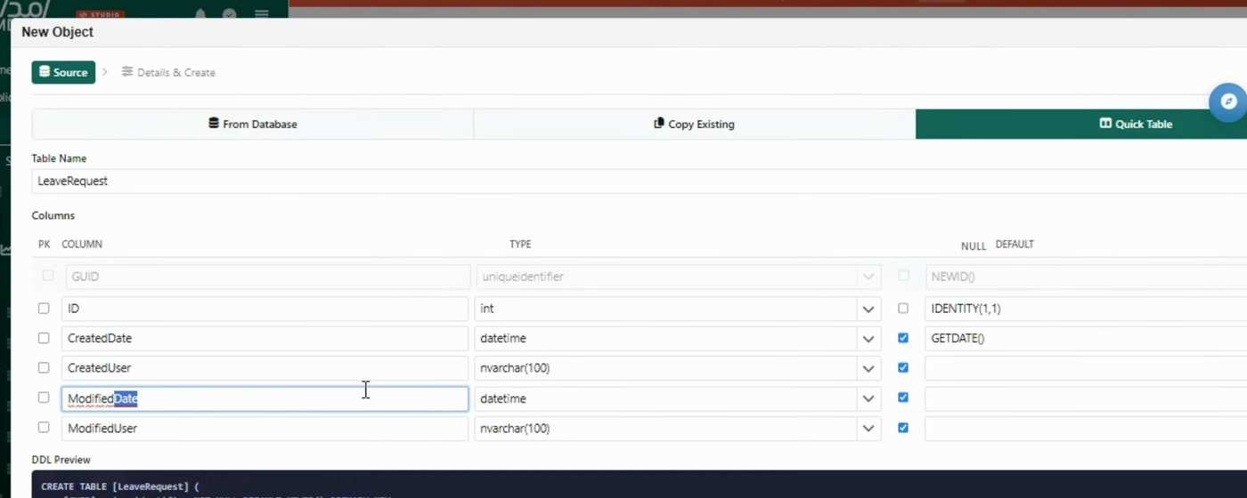
Figure 1 - Quick Table previews physical SQL DDL (recording approximately 40:00).
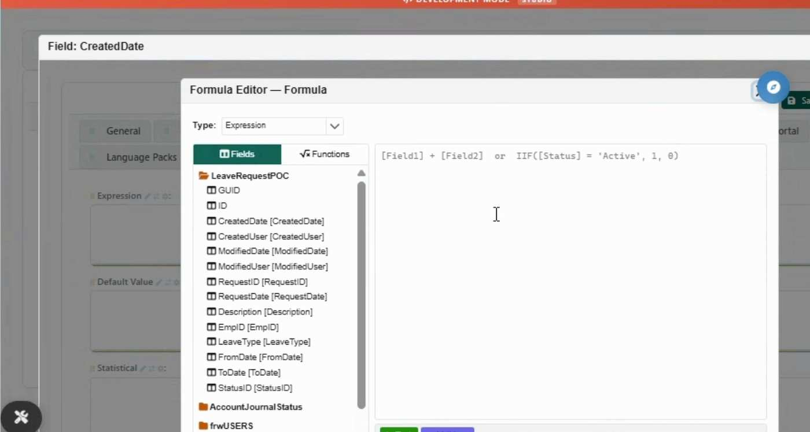
Figure 2 - Formula Editor exposes local Test and Validate actions (recording approximately 50:00).
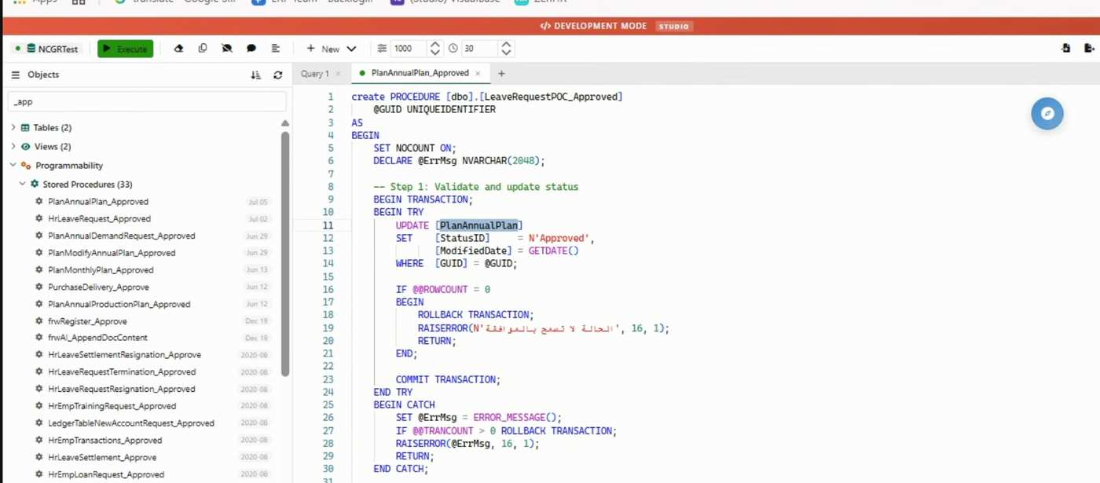
Figure 3 - SQL Studio directly edits an approval stored procedure (recording approximately 72:30).

What the POC demonstrated
- Fast creation of data-centric screens and administrative workflows.
- A new database-backed object and generated form were composed during the recorded session.
- The field formula editor provides local Test and Validate helpers.
- Approval sequence, hierarchy, formula, percentage, event, and escalation options are configurable.
- Bilingual and right-to-left support is designed into the platform model.
- Built-in reporting, export, reminders, approvals, audit options, and notification channels.
- Consistent generated UI and centralized metadata can reduce the initial amount of repetitive CRUD code.
- Runtime flexibility can be valuable for prototypes and low-risk departmental applications where speed matters more than deep domain behavior.
These capabilities are credible reasons to consider VisualBase for data-centric administrative scope. They should be recognized in the decision rather than dismissed.

What the POC did not demonstrate
- Correct behavior under competing stock reservations, simultaneous issues/receipts, duplicate messages, partial failure, backdating, reversals, and period closure.
- Automated regression coverage for rules stored in metadata tables, SQL expressions, views, procedures, event hooks, approvals, and generated screens. The observed Formula Editor Test/Validate actions are local helpers, not evidence of a regression suite.
- A reproducible release chain that links every metadata and database change to Git review, automated tests, a signed artifact, promotion approval, and rollback evidence. The recording showed same-session metadata, DDL, SQL, and generated-runtime work without that chain being demonstrated.
- Least-privilege database access, safe parameterization of dynamic SQL, separation of duties, tamper evidence, dependency/SBOM controls, or independent security testing.
- Measured performance, load behavior, contention handling, backup restoration, disaster recovery, observability, incident tracing, and support readiness against NCGR targets.
- Stable NCGR-owned APIs with versioning, idempotency, replay, error contracts, integration monitoring, and reconciliation.
- Independent platform ownership: clean build, deploy, restore, patch, upgrade, and support by NCGR or a replacement supplier without vendor assistance.
POC conclusion: The POC proved functional acceleration, not production-platform fitness. The missing evidence concerns the highest-impact risks for an inventory and production system of record.

Why VisualBase is a poor fit for inventory and production

1. Complexity is hidden, not eliminated
A database-driven runtime replaces explicit code with a combination of tables, views, procedures, runtime metadata, event names, SQL expressions, approval configuration, and generated screen behavior. The total system may require fewer source files, but an engineer must reconstruct behavior across more implicit links. This increases the cost of understanding impact, especially when a change affects stock, production, approvals, accounting, and reporting at the same time.
- There is no compile-time type system proving that a rule, field, procedure parameter, status, or event contract still matches its callers.
- A renamed column, changed view, modified stored procedure, or edited metadata row can alter runtime behavior outside an application release.
- The same generic platform controls many modules, so platform or metadata defects can have a broad blast radius.
- Engineers become dependent on vendor-specific runtime semantics and database conventions that are harder to transfer to standard .NET teams.

2. Domain invariants are harder to make explicit and test
Inventory and production are not CRUD domains. Their correctness depends on invariants that must hold across multiple records and concurrent operations. Examples include preventing negative available balance when a reservation exists, keeping units of measure consistent, enforcing work-order states, consuming only approved BOM versions, maintaining serial/lot traceability, and reversing postings without rewriting history.
VisualBase can call validations, SQL queries, events, and approval workflows. That demonstrates extensibility, but not that invariants are represented as cohesive domain behavior with isolated unit tests, concurrency tests, and stable interfaces. When logic is dispersed between runtime records and database objects, correctness becomes a property of the whole configured database, not a property that can be proven module by module before release.

3. Runtime editability conflicts with controlled change
The vendor presents on-the-fly programming as a feature [S1][S2]. For a government system of record, the same capability is a governance risk unless every change is exported to source control, peer reviewed, tested in an equivalent environment, approved, deployed as an immutable artifact, and reconciled after release. The observed Version Control & Tools screen contains version fields and QA checklist flags; that is not evidence of Git-grade diffs, mandatory reviews, reproducible builds, automated tests, signed releases, or database migration provenance.
The recording makes this concern concrete: Development Mode, Quick Table DDL, object metadata, formulas, approvals, SQL Studio, and generated runtime behavior were used within one tenant/session [S11]. That is a strong rapid-iteration experience, but no promotion boundary from development to a controlled runtime was demonstrated.

4. The database becomes an oversized trust boundary
If the database stores business data, application definitions, security metadata, validation SQL, and procedural business logic, then database compromise or misconfiguration affects both data and application behavior. Database deployment privileges may become equivalent to application-code deployment privileges. The presence of SQL Query, Insert Command, and Update Command fields increases the importance of strict parameterization, least privilege, segregation of duties, approval, tamper evidence, and runtime monitoring. This review did not verify those controls.
The demo exposes useful per-object security and audit switches, but checkboxes do not establish enforcement. NCGR would still need evidence for authorization at every service boundary, row/field filtering, administrative action logging, privileged-access monitoring, secret management, patching, and secure development in line with ECC 2-2024 [S9].

5. Testing and release assurance are weak by default
The Formula Editor's Test and Validate actions are useful local feedback, but they do not establish regression coverage across metadata, procedures, workflow, generated screens, and integrations. At approximately 72:30, the in-progress SQL editor showed a new LeaveRequestPOC_Approved signature while the copied body and tab still contained PlanAnnualPlan references [S11]. This is not reported as a production defect. It is direct evidence that manual copy/edit is part of the workflow and must be caught by repository review and automated tests.
- Rules stored as data are not automatically covered by unit tests, mutation tests, or static analysis.
- Stored procedures and views can be versioned and tested, but the platform does not by itself guarantee that practice or link each change to an application release.
- A test database must reproduce application metadata, schema, procedures, seed data, permissions, jobs, reports, and runtime engine version to be representative.
- Regression scope expands quickly because generic engine behavior and metadata conventions are shared across modules.
- Rollback is difficult when data, metadata, and procedures change together; reverting code without reconciling data may be unsafe.

6. Observability and incident response become database archaeology
A production incident should be traceable through one correlation ID from API request to domain command, database transaction, background job, event, and external integration. In the observed model, behavior may cross generated forms, validation rows, SQL queries, procedures, workflow configuration, and server events. Without structured telemetry that exposes those transitions, root-cause analysis depends on reconstructing runtime configuration and database state at the time of failure.

7. Integration contracts are not the center of the design
NCGR inventory and production will need stable interfaces to procurement, finance, identity, document management, reporting, notifications, master data, and possibly physical or industrial systems. Database tables and stored procedures are poor public contracts: they expose persistence details, are difficult to version independently, and encourage shared-database coupling. A service/API-first application can publish versioned contracts, validate commands, enforce authorization, and use idempotent messages with an outbox/inbox pattern.

8. Product lifecycle and ownership need clarification
The public Visualsoft lifecycle table lists VisualBase 7.1 as a 2019 release with mainstream support through 2029, and VisualBase 7.0 with support through 2027 [S3]. The authenticated runtime displayed a 'VisualBase 2026' label. This may be a different release scheme, but NCGR should not infer support from branding. Procurement must reconcile the deployed version, engine build, dependencies, support end date, patch policy, SBOM, source escrow or exit rights, and support SLA before any further platform commitment.

Source-code handover and vendor lock-in
The proposed handover of the platform source code after project completion is beneficial, but it is not equivalent to eliminating vendor lock-in. The statement is stakeholder-provided and the exact contract language, timing, scope, intellectual-property rights, third-party components, and acceptance conditions were not reviewed [S5].
Key distinction: Source possession means NCGR receives files. Operational independence means NCGR can understand, build, test, secure, deploy, restore, patch, upgrade, and transfer the platform without vendor assistance. The contract must secure the second outcome, not only the first.

Five layers of lock-in
Layer | Why source files are insufficient | Current position
Legal rights | Source may be delivered without perpetual rights to modify, operate, sublicense to a replacement supplier, or use embedded third-party components. | Contract gap unverified
Build and update toolchain | Files may depend on undocumented generators, license servers, signing keys, installers, private packages, proprietary designers, or vendor-only release knowledge. | Independence unproven
Architecture | NCGR applications remain coupled to the proprietary runtime, metadata parser, event model, and database conventions even when the runtime source is available. | Structural lock-in remains
Data and logic model | Rules spread across metadata, SQL, procedures, views, workflow, and generated objects make extraction or later replacement costly. | Exit cost remains
Knowledge and skills | A small specialist ecosystem and undocumented runtime behavior can make maintenance dependent on vendor-trained personnel. | Capability gap unproven

Required source-handover acceptance tests
If VisualBase remains under consideration, the following should be contractual acceptance and payment gates performed before material dependency accumulates—not a final archive delivered after the project is complete.
- Rights and completeness. NCGR receives the complete platform, generators/designers, runtime, database definitions, build scripts, deployment scripts, tests, documentation, licenses, third-party notices, and SBOM, with permanent rights to operate, modify, audit, and appoint a replacement supplier.
- Clean-room build. An NCGR-selected team builds the platform from a clean environment using only the handed-over repository and documented prerequisites; no vendor workstation, private package feed, or undisclosed license service is required.
- Independent deployment and recovery. The independent team deploys to a new environment, initializes databases, restores backup, rotates secrets/certificates, runs smoke tests, and meets agreed RPO/RTO.
- Change and release. The independent team changes one platform component and one application rule, runs automated regression/security tests, produces a signed release, promotes it, observes it, and performs a safe rollback.
- Security and maintenance. NCGR can reproduce dependency scans, patch a component, rebuild, validate database permissions, monitor privileged changes, and remediate a vulnerability within the agreed SLA.
- Upgrade and transfer. The team upgrades from the accepted version, preserves customer applications and metadata, and transfers support to a third party using the supplied architecture, operations, and troubleshooting documentation.
Contract recommendation: Move source access or escrow, clean-room reproducibility, documentation, training, and independent release evidence into staged acceptance milestones. Waiting until project completion allows dependency to accumulate before NCGR can test whether the handover is usable.

Inventory and production correctness requirements
The decisive question is not whether a screen exists for BOMs, vouchers, receipts, or finished goods. It is whether the system can preserve the following invariants under concurrency, failure, correction, integration retries, and audit. The demo did not provide sufficient evidence for these capabilities.
Capability | Required invariant | Current evidence
Inventory ledger | Every physical or financial stock change is an append-only posting with source, actor, timestamp, quantity, UOM, location, and correlation ID; correction occurs through reversal or adjustment, not silent update. | Not demonstrated
Balance model | On-hand, reserved, available, in-transit, quarantined, damaged, and rejected quantities reconcile deterministically by item/location/lot/serial/status. | Not demonstrated
Concurrency | Simultaneous issue, receipt, reservation, transfer, and count operations cannot oversubscribe or double-post stock. | Not demonstrated
Idempotency | Retried API calls, jobs, and integration messages produce one business effect. | Not demonstrated
Units and conversion | Conversions are effective-dated, precision-controlled, and consistent across procurement, inventory, production, and reporting. | Partially visible only
Traceability | Serial/lot genealogy supports recall, inspection, quarantine, release, and full upstream/downstream trace. | Screens visible; behavior unverified
BOM governance | BOM/formula versions, alternates, scrap factors, validity dates, approvals, and effectivity are immutable once used by production. | Screens visible; behavior unverified
Production lifecycle | Work orders enforce release, issue, consume, report, receive, close, cancel, rework, yield, and variance rules. | Not demonstrated
Period and backdating | Posting dates, closed periods, retroactive changes, costing, and downstream reconciliation are controlled. | Not demonstrated
Audit and reversal | Approvals, postings, privileged changes, reversals, and data fixes are attributable and tamper-evident. | Configuration visible; enforcement unverified

Finding: A generated screen named 'BOM' or 'Finished Goods Receipt and Delivery' is feature presence, not proof of transactional correctness.

Comparative engineering assessment
The comparison below evaluates the observed architecture, not vendor marketing breadth. ABP is treated as a foundation for NCGR-owned code, not as a packaged inventory product. The result is intentionally balanced: VisualBase has a real initial-delivery advantage; .NET/ABP has higher upfront engineering effort but materially stronger ownership and assurance potential.
Area | VisualBase assessment | .NET + ABP treatment | VB risk
Domain model | Rules dispersed across metadata and SQL; implicit coupling. | Typed aggregates, value objects, policies, and application services owned by NCGR. | RED
Change traceability | Runtime-editable records and DB objects; Git/release linkage unverified. | Pull requests, code review, signed build artifacts, EF Core migrations, release tags. | RED
Automated testing | Whole configured database must be reproduced; rule coverage unverified. | Unit, integration, contract, concurrency, migration, and end-to-end tests in CI. | RED
Authorization | Per-object flags and security groups visible; enforcement depth unknown. | ABP permission system plus ASP.NET Core authorization and resource policies. | AMBER
Auditability | Audit options visible; correlation and tamper evidence unknown. | ABP audit logging, structured telemetry, correlation IDs, immutable business postings. | AMBER
Integration | Database-centric behavior encourages shared schema/procedure coupling. | Versioned APIs, integration services, events, outbox/inbox, idempotency keys. | RED
Operability | Runtime path spans engine, metadata, SQL, events, and workflows. | Observable service boundaries with logs, metrics, traces, health checks, and job monitoring. | RED
Vendor lock-in | Business definitions depend on proprietary engine semantics. | NCGR-owned C# domain code on open .NET/ABP framework; commercial modules optional. | RED
Promised source handover | Reduces legal continuity risk only if rights and clean-room operation are proven; proprietary architecture remains. | Application source, build, tests, pipeline, and domain knowledge are owned from the first sprint. | AMBER
Skills and suppliers | Specialist knowledge of the runtime and metadata conventions is required. | Broad .NET/SQL engineering market; ABP-specific knowledge is transferable from standard ASP.NET Core/DDD skills. | AMBER
Initial CRUD speed | Strong; forms and grids generated rapidly. | Moderate; ABP Suite can generate CRUD, but critical workflows require domain code. | GREEN
Long-term adaptability | Fast local changes but increasing implicit coupling and regression risk. | Slower disciplined changes; stronger modularity, contracts, and regression assurance. | RED

Why .NET 10 LTS and ABP
ABP is a current, documented enterprise application framework on ASP.NET Core. The official documentation lists a modular layered architecture based on domain-driven design, multi-tenancy infrastructure, event bus, background jobs, audit logging, data filtering, validation, authorization, exception handling, localization, caching, and dependency injection [S6]. As of this assessment, ABP 10.6 is the latest stable documentation track and ABP 10 is aligned with .NET 10 [S6][S7]. Microsoft lists .NET 10 as an active LTS release supported through 14 November 2028 [S8].
The architectural benefit is not that ABP removes coding. It provides repeatable infrastructure so NCGR can place business behavior in typed, reviewed C# modules while avoiding reimplementation of common enterprise concerns. ABP Suite can generate CRUD pages, but generated CRUD must remain a delivery aid, not the domain architecture [S6].

Recommended use of ABP
- Start with a modular monolith - separate domains and data ownership in one deployable solution before considering microservices. This reduces distributed-system risk while preserving boundaries.
- Use Domain-Driven Design selectively - apply aggregates, value objects, domain services, specifications, and policies to rules that protect inventory and production integrity.
- Keep SQL Server - use it for durable persistence, transactions, constraints, indexes, and read-optimized views. Do not use it as the primary orchestration or policy layer.
- Use EF Core migrations - version schema changes with the application and test forward/backward compatibility. Retain stored procedures only for bounded, measured needs and version them as source.
- Adopt API-first integration - publish versioned application contracts; protect them with OpenID Connect/OpenIddict and permission/resource policies.
- Build for operations - structured logs, metrics, traces, health checks, job dashboards, correlation IDs, and deployment metadata are part of the first production slice.

ABP caveats
- ABP is an application framework, not a complete inventory or manufacturing product. NCGR still owns domain discovery, rules, integrations, testing, and operations.
- The free/open-source offering provides core framework capabilities; commercial licenses add professional modules, templates, ABP Suite, themes, and premium support [S10]. Procurement should decide deliberately whether those benefits justify the license.
- ABP version upgrades and .NET patching still require an owned lifecycle. Current patches are required to remain supported under Microsoft's policy [S8].
- Avoid unnecessary microservices, generic repositories exposed as APIs, anemic entities, and a second metadata-driven rule engine that recreates the same problem.

Proposed target architecture
Architecture style: Modular monolith first; domain modules with explicit ownership; API-first integration; event-driven side effects; SQL Server persistence; independently testable boundaries.

Logical flow
Web / mobile / integration clients -> ABP APIs and authorization -> application commands -> domain modules -> SQL Server + outbox + read models

Recommended modules and ownership
Module | Responsibility | Data ownership
Identity & Organization | Users, roles, permissions, organization units, delegations, service identities. | Identity records and access policy
Product & Material Master | Items, categories, UOM, conversions, variants, serialization/lot policy, specifications. | Master definitions
Warehouse | Sites, stores, locations, bins, capacity, put-away/picking policy. | Storage topology
Inventory Ledger | Postings, balances, reservations, transfers, counts, quarantine, adjustments, reversals. | Immutable stock movements
Production | BOM/formula versions, work orders, material issue/consumption, finished goods, yield, scrap, rework. | Production state and genealogy
Quality & Inspection | Inspection plans, results, holds, release/reject decisions, nonconformance. | Quality decisions
Workflow & Approvals | Business approval policies, tasks, escalation, delegation, decision history. | Approval state; not stock state
Integration | Procurement, finance, notifications, documents, external systems, idempotency, mapping. | External contracts and outbox/inbox
Reporting & Audit | Read models, operational reports, audit queries, reconciliations, evidence exports. | Derived read data; no transaction writes

Non-negotiable engineering guardrails
- Only the owning module writes its transactional tables; reporting views and integrations are read-only unless they call an application command.
- Inventory movements are append-only business postings. Corrections use reversal or adjustment with reason, actor, and correlation to the original posting.
- Every externally retriable command has an idempotency key and deterministic outcome.
- Cross-module and external side effects use an outbox/inbox pattern; a database commit never depends on a synchronous external callback.
- Authorization is enforced in application services and resource policies, not only in UI visibility or database roles.
- Database changes are source controlled, peer reviewed, tested, and deployed through the same release pipeline as application code.
- No production runtime editing of business rules outside an approved, audited configuration model with schema, ownership, version, effective date, and test coverage.
- Every command carries correlation, actor, tenant/legal entity, source, and causation metadata into logs and business audit records.

Greenfield implementation approach
Inventory and production development has not started. This is therefore a platform-selection and greenfield implementation decision: there is no VisualBase inventory/production application to replace, no legacy behavior to reproduce, and no cutover to plan. NCGR should define the business domain first and establish the governed .NET/ABP foundation before implementing transactional scope.
Gate | Stage | Required outcome
1 | Decision and domain baseline | Approve the platform decision and document actors, processes, policies, terminology, responsibilities, accounting impacts, and measurable outcomes with business owners.
2 | Foundation | Create the ABP solution, identity/organization model, permission taxonomy, audit/correlation, CI/CD, observability, database migration system, secrets, environments, and security gates.
3 | Inventory vertical slice | Implement product/material master, warehouse topology, inventory ledger, receipts, issues, transfers, reservations, counts, adjustments, and reconciliation for one bounded process.
4 | Production slice | Implement effective-dated BOM/formula, work orders, consumption, finished-goods receipt, quality hold/release, yield/scrap, and traceability.
5 | Integration and data onboarding | Add procurement, finance, identity, document, and notification contracts; define authoritative sources; and validate initial master data and opening balances with repeatable reconciliation.
6 | Production readiness and rollout | Complete security, performance, resilience, operational, user-acceptance, and reconciliation gates before a controlled rollout to additional warehouses and production processes.

What must happen before coding
- Create a business-rule catalog. For every inventory, production, quality, approval, costing, and period rule, identify the policy source, owner, affected data, failure behavior, and executable acceptance examples.
- Define the inventory ledger. Agree the posting model, balance dimensions, reservation semantics, status transitions, reversal model, and reconciliation equations.
- Define production lifecycles. Document BOM/formula effectivity, work-order states, issue/consume/receive transitions, quality gates, yield, scrap, rework, and closure.
- Define integration contracts. Specify authoritative systems, identifiers, idempotency, retries, ordering, error recovery, and reconciliation for each dependency.
- Set measurable non-functional targets. Transactions per second, peak concurrency, response time, data volume, batch windows, availability, RPO/RTO, audit retention, and security objectives.
- Approve a data-onboarding evidence plan. Every imported master record, opening balance, serial/lot record, and open transaction must reconcile to an approved authoritative source using repeatable, source-controlled scripts.

Platform decision gates
These gates are conjunctive. VisualBase should be approved only if every critical gate is proven with repeatable evidence by NCGR or an independent team. The current POC result is not a weighted score in which fast CRUD delivery can offset a failed ownership, correctness, security, or recovery gate.
Gate | Evidence required | POC result | Status
Domain correctness | Concurrent reservation/issue, idempotent receipt, BOM effectivity, genealogy, reversal, backdating, and reconciliation scenarios pass automated tests. | Unproven | RED
Change governance | All platform metadata, rules, SQL objects, and configuration are diffable, peer reviewed, tested, promoted, signed, auditable, and safely reversible. | Unproven | RED
Security boundary | Least-privilege roles, safe dynamic SQL, segregation of duties, tamper evidence, dependency controls, and independent security tests meet NCGR/NCA requirements. | Unproven | RED
Operations and resilience | Load, contention, observability, backup/restore, DR, patching, incident tracing, and support ownership meet measurable SLO/RPO/RTO targets. | Unproven | RED
Integration contracts | Versioned APIs, authorization, idempotency, replay, error handling, monitoring, and reconciliation are NCGR-owned and demonstrated. | Unproven | RED
Independent ownership | NCGR or a replacement supplier passes the clean-room source build, deploy, recovery, change, security patch, upgrade, and transfer tests. | Unproven | RED
Functional acceleration | Bilingual forms, workflow, approvals, reports, and centralized configuration were demonstrated in the POC. | Demonstrated | GREEN

Decision result: One demonstrated speed gate does not outweigh six unproven critical gates. The evidence therefore supports not starting the strategic product on VisualBase.

Acceptance gates for production
Gate | Evidence required
Domain correctness | Automated invariant, concurrency, idempotency, reversal, and reconciliation tests pass; golden business scenarios are signed off.
Data onboarding | Initial master data, opening balances, serial/lot records, and any approved open transactions reconcile to authoritative sources with zero unexplained variance.
Security | Threat model, code review, dependency scanning, secrets review, SAST/DAST, penetration test, permission testing, and ECC evidence are complete.
Reliability | Load, soak, failover, backup restore, DR, queue retry, and database recovery tests meet approved SLO/RPO/RTO targets.
Operations | Dashboards, alerts, runbooks, support ownership, on-call escalation, correlation tracing, privileged-change monitoring, and deployment rollback are proven.
Release governance | Signed artifacts, environment promotion, database migration provenance, approvals, segregation of duties, and production change records are enforced.
Business readiness | Process owners approve workflows, training, role mappings, reports, rollout sequencing, fallback procedures, and post-go-live reconciliation.

Immediate next actions
- Record the architecture decision. Approve an ADR before development begins: VisualBase is not the strategic foundation for NCGR inventory and production; .NET 10 LTS and ABP are the target foundation.
- Start a domain discovery sprint. Map ledger, reservation, serial/lot, inspection, BOM, production, quality, approval, costing, and integration rules with accountable business owners.
- Define measurable quality attributes. Set transaction volumes, peak concurrency, response times, batch windows, availability, RPO/RTO, audit retention, security, and support targets before solution design is accepted.
- Establish the engineering foundation. Create repositories, branching and review policy, CI/CD, environments, dependency and secret controls, database-change governance, observability, and architecture decision records.
- Build one vertical proof. Implement a rigorous .NET/ABP slice: product/UOM, receipt command, immutable posting, balance projection, reversal, authorization, audit, tests, and reconciliation.
- Authorize broader development on evidence. Expand scope only after the vertical slice passes agreed correctness, concurrency, security, performance, operability, and maintainability gates.

Final recommendation
Based on the current POC evidence, NCGR should not use VisualBase as the strategic foundation for inventory and production. The platform is optimized for dynamic, database-centric application generation and has a credible initial speed advantage. NCGR's target workload, however, requires a governed transactional product whose rules are explicit, owned, testable, observable, and independently deployable. The recommended move is to start the greenfield implementation on .NET 10 LTS and ABP, delivered as a modular monolith with SQL Server persistence and evidence-based production gates. The recording does not reverse this recommendation: it increases confidence in the platform's functional acceleration and makes the change-governance gap more concrete. Because development has not started, NCGR can make the foundation decision before application and supplier dependency accumulates.
No-go statement: Do not approve starting inventory or production development in VisualBase on the current evidence. Begin with the governed .NET/ABP foundation and implement verified domain slices. If leadership keeps VisualBase as an option, require every platform decision gate and clean-room source-handover test to pass before approval.

Sources
[S1] Visualsoft - VisualBase product page. Vendor claims for runtime development, SQL-based customization, workflow, security, reporting, and multilingual support. Accessed 1 September 2026.
[S2] Google Patents - US8782095B2, Method and system for programming at run-time and dynamic business application. Vendor-linked technical description of the runtime engine, database repositories, generated screens, rules, and data access model. Accessed 1 September 2026.
[S3] Visualsoft - Products Lifecycle Policy. Public VisualBase release years and mainstream support end dates. Accessed 1 September 2026.
[S4] Authenticated NCGR VisualBase POC. Direct observations recorded 1 September 2026; access-controlled and not a public source. Accessed 1 September 2026.
[S5] Stakeholder-provided contract context. Vendor is expected to provide the no-code platform source after project completion; exact legal scope and acceptance terms were not reviewed.
[S6] ABP Documentation - latest stable documentation. ABP architecture, infrastructure, cross-cutting concerns, tools, modules, and source model. Accessed 1 September 2026.
[S7] ABP Release Notes. ABP 10.6 latest stable track and .NET 10 alignment. Accessed 1 September 2026.
[S8] Microsoft - .NET and .NET Core Support Policy. .NET 10 LTS lifecycle, patching, and end-of-support date. Accessed 1 September 2026.
[S9] Saudi National Cybersecurity Authority - Essential Cybersecurity Controls. Current ECC 2-2024 control baseline for national entities. Accessed 1 September 2026.
[S10] ABP FAQ - free and commercial licenses. Distinction between the free framework and commercial tooling/modules/support. Accessed 1 September 2026.
[S11] Recorded VisualBase development UX. 80:08 screen recording dated 27 August 2026 and reviewed 2 September 2026; direct observations are time-coded in the report. Audio discussion was treated as contextual only; findings rely on visible workflow evidence.

Appendix A - Evidence interpretation
- Observed means visible in the authenticated demo UI or recorded development workflow. It does not prove the underlying implementation or control effectiveness.
- Vendor-stated means described in public vendor material. It is useful architectural evidence but not independent assurance.
- Stakeholder-provided means supplied in the assessment request and should be verified against database/source artifacts.
- Not demonstrated means the review found no sufficient evidence; it does not mean the capability cannot exist.
- The recommendation is architecture- and evidence-led. A later proof can change an unproven gate, but approval requires all critical gates to pass; strengths in one area do not average away a critical failure.

Appendix B - Vendor challenge questions
- Show one business-rule change from requirement to Git diff, peer review, automated test, signed release, database deployment, production audit, and rollback.
- Demonstrate how runtime metadata changes are prohibited in production or exported, reviewed, promoted, reconciled, and tamper-evident.
- Provide the exact deployed version, dependency/SBOM inventory, patch cadence, CVE response SLA, support end date, source-handover clauses, and exit rights.
- Demonstrate transaction isolation and concurrency behavior for two simultaneous issues against the same available stock.
- Demonstrate idempotent retry for receipt, transfer, and finished-goods posting across application and integration failure.
- Demonstrate immutable reversal and full reconciliation from source document to inventory balance and downstream finance posting.
- Provide API definitions, versioning policy, authentication/authorization model, throttling, monitoring, error model, and integration replay/reconciliation design.
- Provide backup/restore and DR test evidence with measured RPO/RTO, including application metadata, business logic repository, data, jobs, reports, keys, and attachments.
- Provide independent penetration-test results, secure-development evidence, least-privilege database roles, privileged-access monitoring, and ECC control mapping.
- Explain how SQL Query, Insert Command, Update Command, server events, and approval events are parameterized, authorized, logged, tested, and prevented from bypassing domain rules.
- Allow an NCGR-selected team to perform the clean-room source build, independent deployment, restore, patch, release, rollback, upgrade, and third-party transfer tests before contractual acceptance.

